**Online Sales – SQL Project**

**Output Screens**

1. **Yearly Grouping**

select

extract(year from “order_date” ) as year

from

orders

group by year;



1. **Year + Month Number Grouping**

select

extract(year from "order_date" ) as year,

extract(month from "order_date") as month_number

from

orders

group by year, month_number

order by month_number;

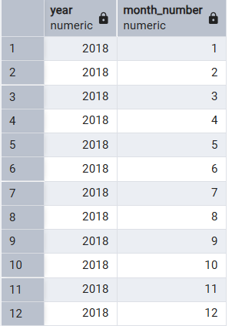

1. **Year + Month Name**

select

extract(year from "order_date" ) as year,

extract(month from "order_date") as month_number,

to_char(order_date, 'Month') as month

from

orders

group by year, month_number, month

order by month_number;

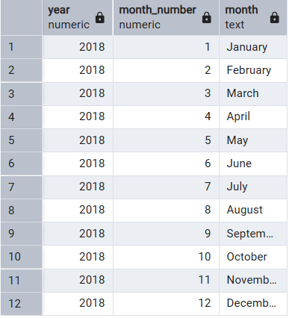

1. **Monthly Revenue**

select

extract(year from o.order_date ) as year,

extract(month from o.order_date) as month_number,

to_char(order_date, 'Month') as month,

sum(d.amount) as total_revenue

from

orders o

join details d

on o.order_id=d.order_id

group by year, month_number, month

order by month_number;

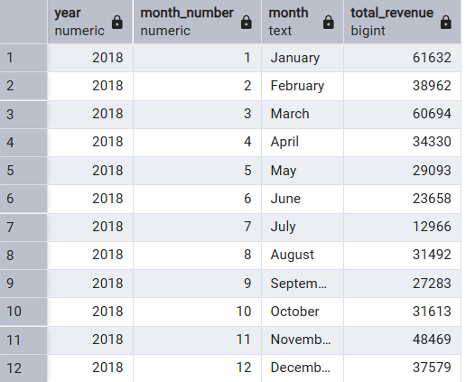

1. **Monthly Revenue + Total Customers**

select

extract(year from o.order_date ) as year,

extract(month from o.order_date) as month_number,

to_char(order_date, 'Month') as month,

sum(d.amount) as total_revenue,

count(distinct o.order_id) as total_customers

from

orders o

join details d

on o.order_id=d.order_id

group by year, month_number, month

order by month_number;

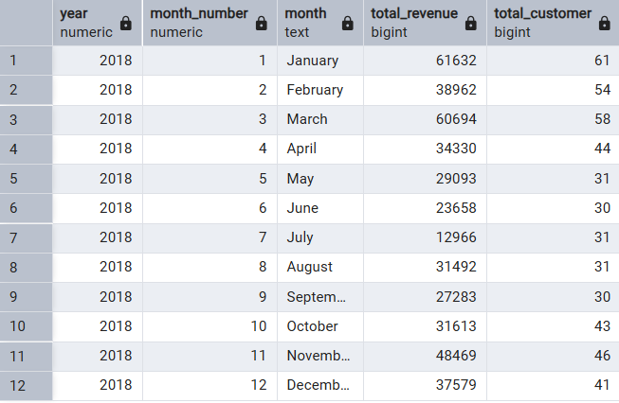

**to_char(order_date, 'FMMonth') as month,**

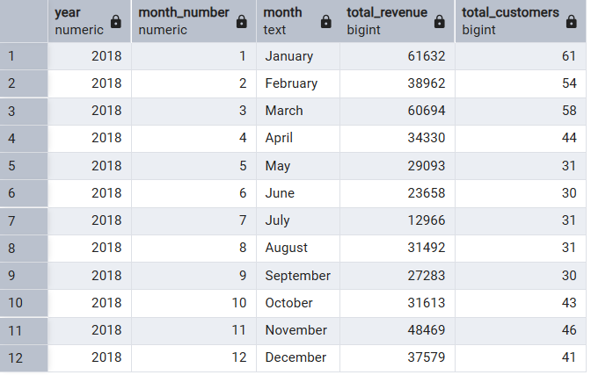

1. **Top 3 Months by Revenue**

select

to_char(order_date, 'FMMonth') as month,

sum(amount) as total_revenue

from

orders o

join details d

on o.order_id=d.order_id

group by month

order by total_revenue desc

limit 3;

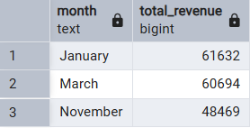

1. **Month with Highest Average Spending Per Customer**

select

extract(month from o.order_date) as month_number,

to_char(o.order_date,'FMMonth') as month,

round((sum(amount)::numeric/count(distinct o.customer_name)),2) as avg_spending

from

orders o

join details d

on o.order_id=d.order_id

group by month_number,month

order by avg_spending desc;

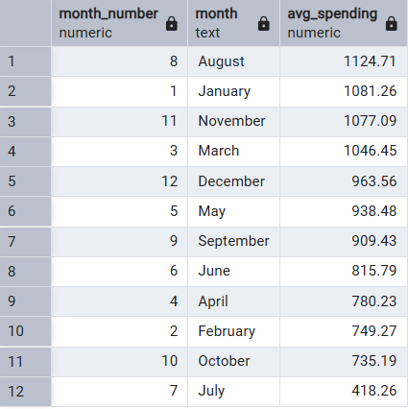

1. **City wise Sales**

select

o.city,

sum(d.amount) as total_revenue

from

orders o

join details d

on o.order_id=d.order_id

group by city

order by total_revenue desc;

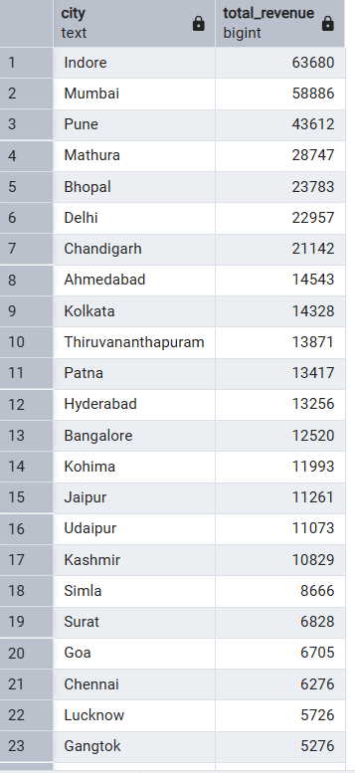

1. **Payment Mode Analysis**

select

d.payment_mode,

count(distinct o.order_id) as total_orders,

sum(d.amount) as total_revenue

from

orders o

join details d

on o.order_id=d.order_id

group by d.payment_mode

order by total_revenue desc;

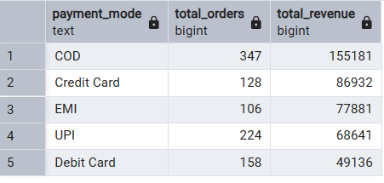

1. **Category by Profit**

select

category,

sum(amount) as total_revenue,

sum(profit) as total_profit

from details

group by category

order by total_profit desc;

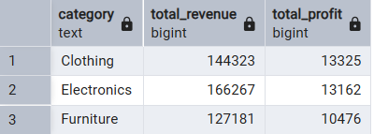

1. **Sub-category Sales by Quantity**

select

sub_category,

sum(quantity) as total_quantity,

sum(profit) as total_profit

from

details

group by sub_category

order by total_quantity desc;

